Tour Consultant WST Travel Ltd

About Next Generation

NGT is the innovative parent company and driving force behind the UK’s fastest growing educational travel brands; offering unique, immersive tours to young people, from 10-21 years, designed to open minds and empower learning.

Our Vision
To be the trusted partner of choice for a broad range of high-quality educational tours and experiences.

Our Mission
To enhance educational outcomes for young people through inspiring, content-rich learning experiences, created by experts who care.

About Next Generation Values and Behaviours

The successful candidate will be expected to behave in a manner equal to the position. This role requires flexibility of hours, passion for service delivery, energy application and vision as required by the business. This role may also require the post holder to stay away from home on occasion.

NGT’s behaviours are to be focused on our customers, to listen actively, to work as a team, to empower others and to show empathy.

NGT’s Behaviours are that we will :

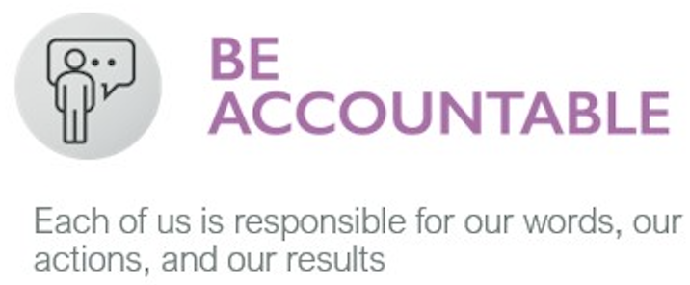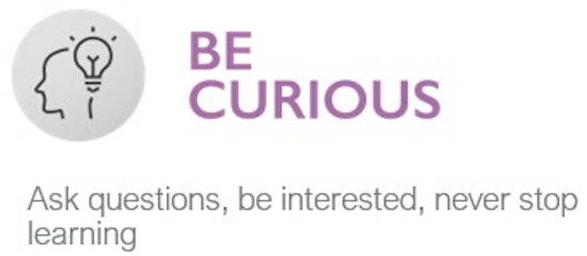
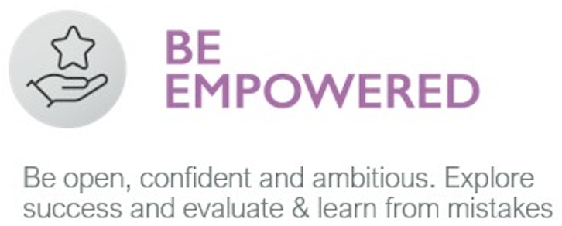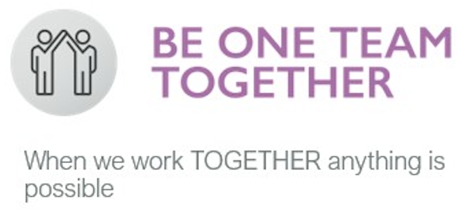

All of the above behaviours will be supported by our experienced Senior Management Team and continual learning practices.

Being part of NGT’s team means that you will benefit from an annually reviewed salary, regular training & development opportunities and working within an exciting, energetic, and innovative culture where reward and recognition are aligned with our success from working together.

About The Role

Title: Tour Consultant

Reporting to: Operations Manager

Location: Bispham, Blackpool

The main focus of this role is to work alongside your colleagues and our clients to deliver an exceptional customer journey by way of handling both verbal and written communication paths in organising all elements of a group tour.

You will liaise with both suppliers and clients direct, to ensure the successful arrangement of the travel, accommodation and required visit elements of the tour. You will be responsible for fully representing the companies service ethic at all times and working within our expected framework of values and behaviours.

Role - Main Responsibilities

- Delivery of exceptional customer service and operational administration for a fluid number of tours throughout the year, including....
  - tailor making itineraries reflecting the requirements of the group
  - generating accurate tour costings,
  - liaising with suppliers / colleagues to negotiate and confirm travel, accommodation and visit requirements
  - ensuring all tours are completed within set budgets and client payments are received in the agreed time frames
  - Development of “life-long” relationships with both client and supplier
- Sound product knowledge, including...
  - regularly visiting assigned areas, taking part in inspection visits
  - maintaining and continually improving information packs about visits in the assigned areas
  - researching subject and destinations in assigned areas to ensure up to date knowledge bank.
  - Understanding and awareness of NGT’s Safety Management System and Health & Safety Rules
  - Understanding of associate memberships and benefit to client & company
- Coaching of less experienced tour consultant colleagues to develop skills and confidence in customer service skills as / when appropriate
- Contribution to identifying improvements to work organisation and procedures etc.

Role - Additional Responsibilities

- After an appropriate qualifying period, you will be required to assist with 24 hour duty officer responsibilities on an occasional basis each year. This requires you to be available during out-of-office hours in order for you to be able to take calls from clients. Full training will be provided.
- Participation in the emergency procedure as required. Full training provided
- Understanding of responsibilities and duties of other departments and the impact on your own.

About The Individual

Individual - Essential Skills Required

- Proven experience and full understanding of delivering exceptional customer service
- Ability to resolve problems, work under pressure and meet deadlines
- Ability to work under own initiative, and essentially as part of a wider team
- Analytical skills
- IT literate and knowledge of Microsoft products
- Ability to follow procedures and willingness to enhance them
- Strong time management skills and ability to prioritise workload and be highly organised
- Excellent verbal and written communication skills and accurate written and spoken English
- Commercial & financial awareness and be numerate
- Adaptable and flexible

Individual - Useful Skills

- Advanced IT knowledge
- Advanced knowledge of the School Travel Market
- Knowledge of a foreign language French/German/Other
- Driving licence
- School Travel Market Product knowledge
- Destination knowledge in particular Europe.

Individual – Essential Personal Attributes

- Self motivated, positive and professional
- Real passion for exceptional service delivery
- Ability to work independently inside a team environment
- Desire to support the development of the business and others
- Flexible, adaptable and positive approach to work
- Free to travel

Individual Additional Information: – Criminal Records Bureau Checks

Due to the nature of the information held and operated by NGT, it is a requirement that all staff members hold current and qualifying CRB checks. Further information can be provided and there would be no charge to the successful applicant should a new or updated check need to be processed.

About the Conditions and Benefits

In addition to a basic salary you will benefit from a commission structure linked to personal performance, a team incentive scheme and a company pension scheme after a qualifying period.

Annual leave entitlement will be 25 days per annum, and un-paid leave can be requested and is subject to approval.

Working Monday to Friday 35 hours per week, with options to work between the hours of 08:00 hrs. and 17:30 hrs., allowing for 60 min lunch breaks. Normal shift patterns include 08:00 – 16:00, 08:30 – 16:30, 09:00 – 17:00, 09:30 – 17.30. Shifts will be business dependent with your line manager.

Flexible working hour requests can also be considered around term time.

WST Travel Ltd is part of Next Generation Travel Limited.

